FilterSwitch V1.0

GJCAMANN © 2014

This allows you to conveniently add a switchable high cut to an existing PCB or VERO layout. Using an ON-OFF-ON solder terminal switch this allow the selection of filter 1, no filter or filter 2. One half of the board is one filter, the other half, the other. For convenience there are two high pads +1 and +2 and two low pads -1 and -2. Connect the high pads to the input to your volume pot and the low pads to ground.

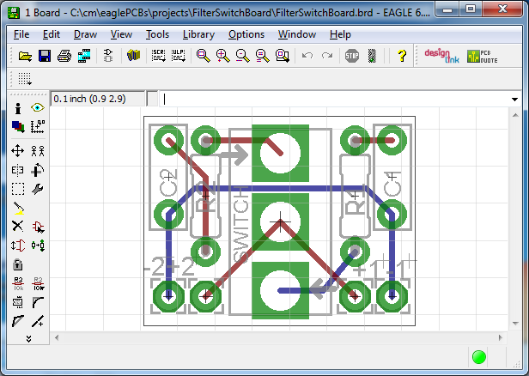 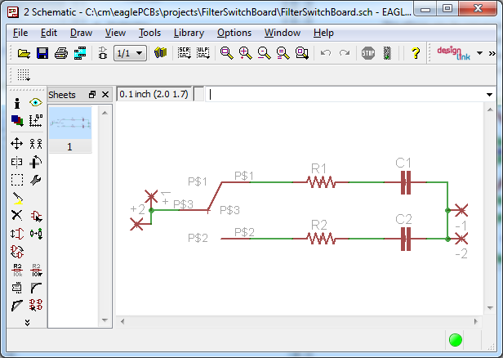

THERE IS NO WARRANTY FOR THIS DESIGN, TO THE EXTENT PERMITTED BY APPLICABLE LAW. THE DESIGN IS PROVIDED “AS IS” WITHOUT WARRANTY OF ANY KIND, EITHER EXPRESSED OR IMPLIED, INCLUDING, BUT NOT LIMITED TO, THE IMPLIED WARRANTIES OF MERCHANTABILITY AND FITNESS FOR A PARTICULAR PURPOSE. THE ENTIRE RISK AS TO THE QUALITY AND PERFORMANCE OF THE DESIGN IS WITH YOU. SHOULD THE DESIGN PROVE DEFECTIVE, YOU ASSUME THE COST OF ALL NECESSARY SERVICING, REPAIR OR CORRECTION.

Licensed under <http://creativecommons.org/licenses/by-sa/4.0/deed.en_US>